3. Salesforce Terminologies - 24 Feb 2022

1] List View

2] Details Page

3] Edit Page

4] Related List

5] In-Line Editing

6] Enhanced Editing

1] List View

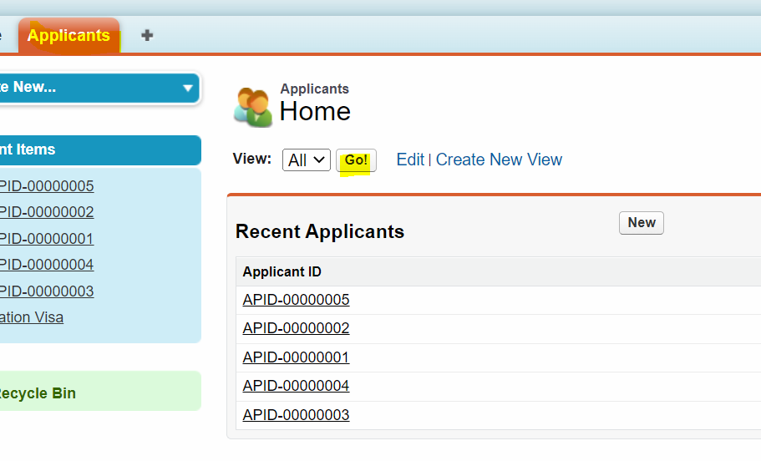

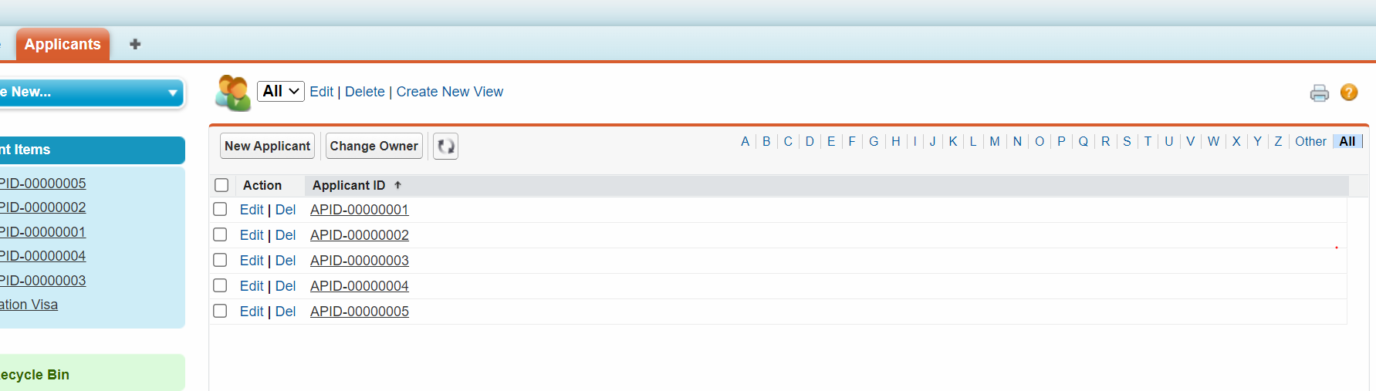

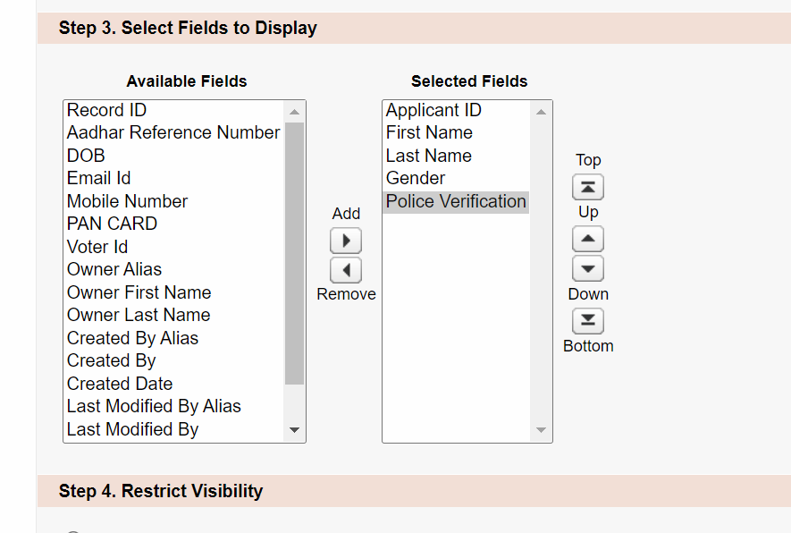

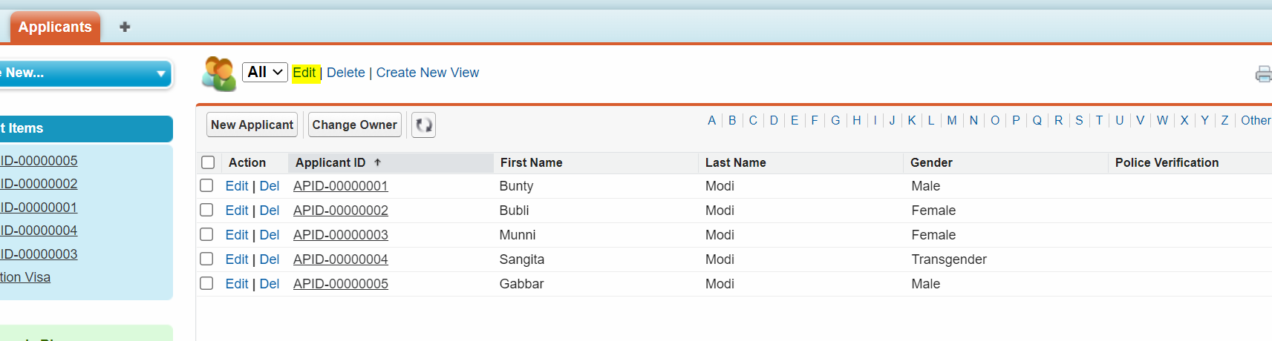

List View of Gender = Male

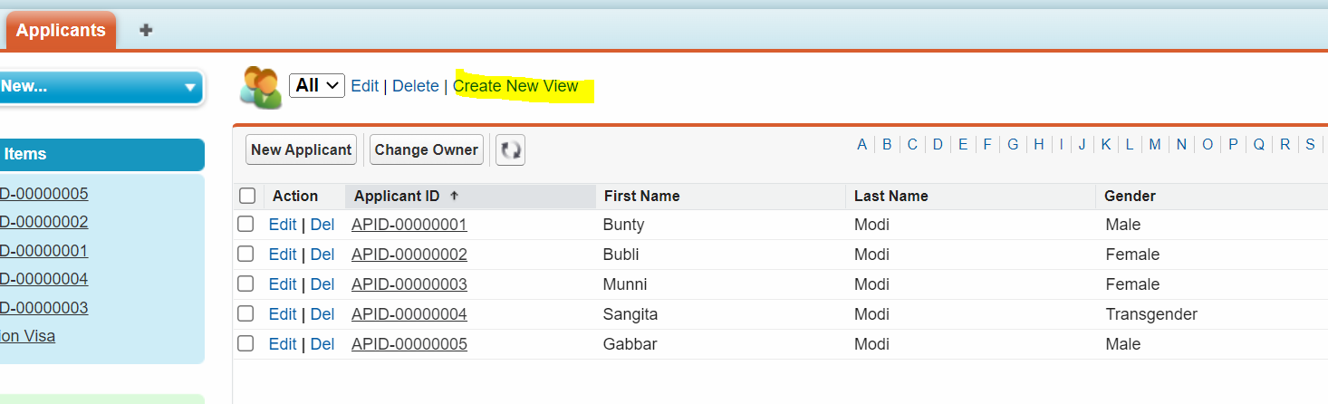

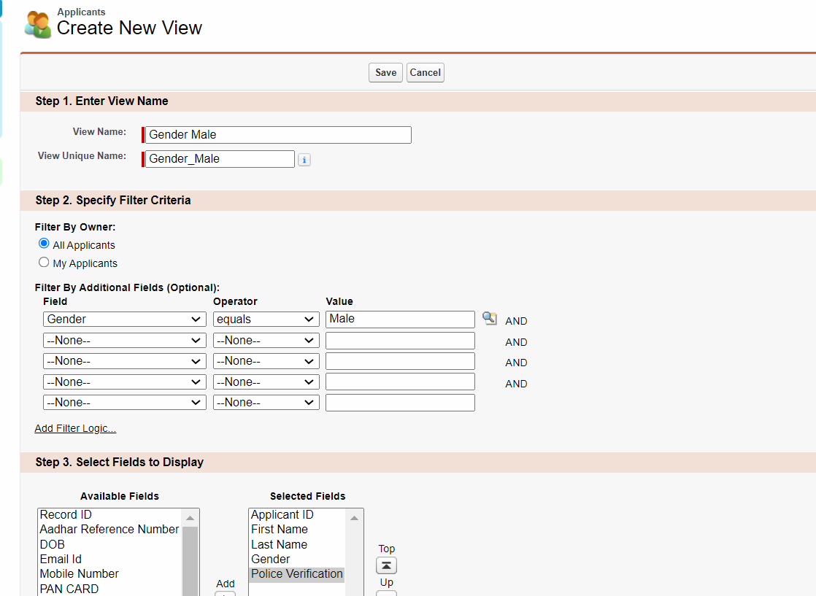

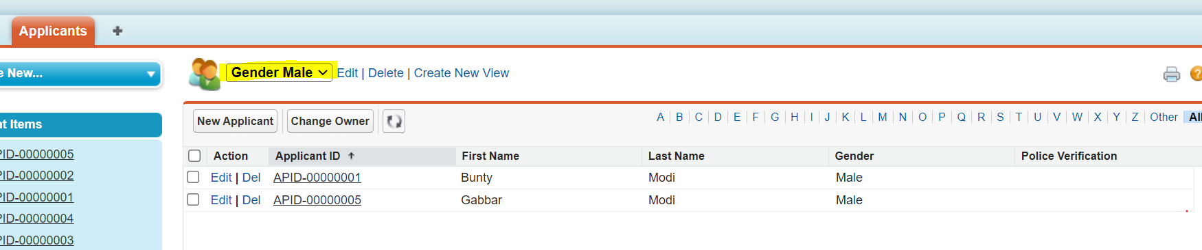

List View : Gender = Female AND Police Verification Eligible

AND Truth Table

|  |  |  |
| --- | --- | --- |
| T | T | T |
| T | F | F |
| F | T | F |
| F | F | F |

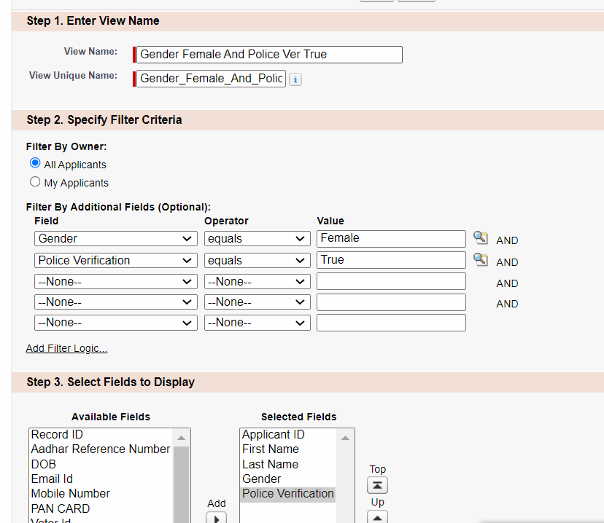

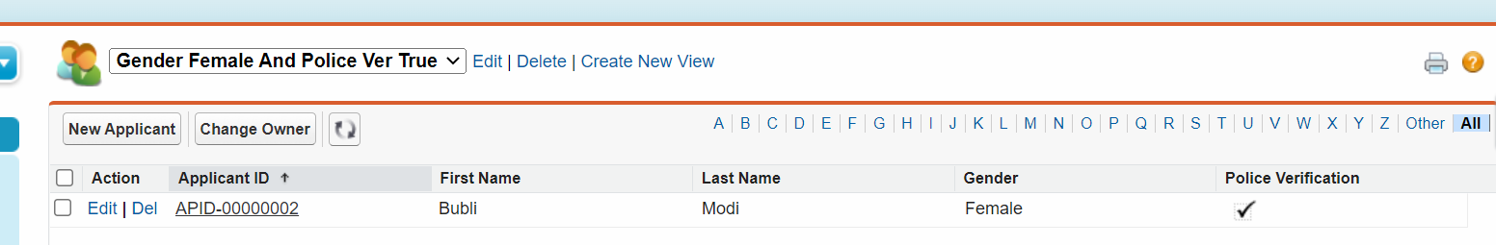

List View : Gender = Male AND Police Verification Eligible OR Email Should not be blank

1 AND (2 OR 3)

OR Truth Table

|  |  |  |
| --- | --- | --- |
| T | T | T |
| T | F | T |
| F | T | T |
| F | F | F |

|  |  |  |  |  |
| --- | --- | --- | --- | --- |
| Name | Gender | Police Verification | Email Id | YES / NO |
| Bunty | Male | TRUE | bunty@gmail.com | T AND (T OR T) |
| Gabbar | Male |  |  | **T AND (F OR F)** |
| Kaliya | Male | TRUE |  | T AND (T OR F) |
| Kabira Speaking | Male |  | kabira@gmail.com | T AND (F OR T) |
| Bubli | Female | TRUE |  | F AND (T OR F) |
| Munni | Female |  |  | F AND (F OR F) |

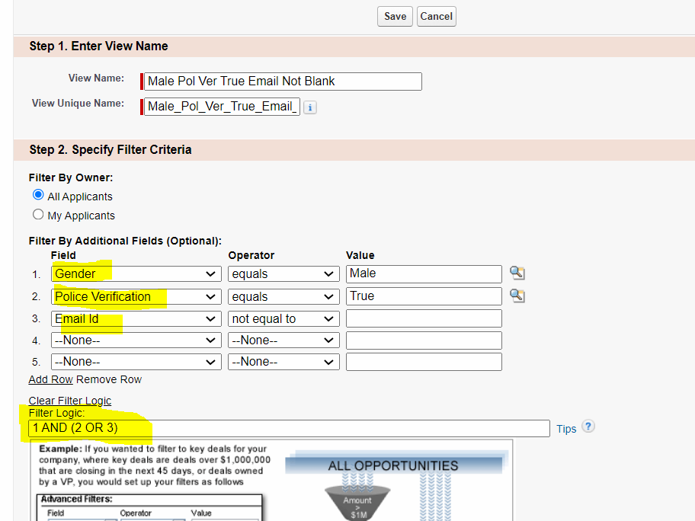

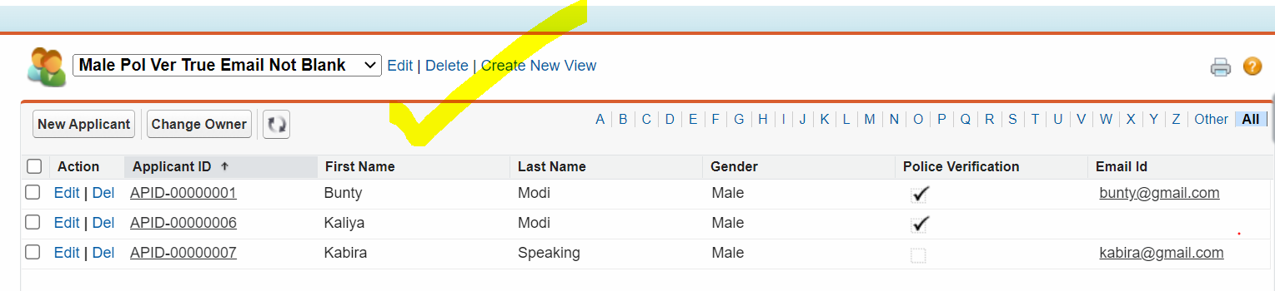

Assignment:

1] Gender Female AND Aadhar Card should be empty or Email Id Empty AND Police Verification Eligible

1 AND (2 OR 3) AND 4

2] Details Page

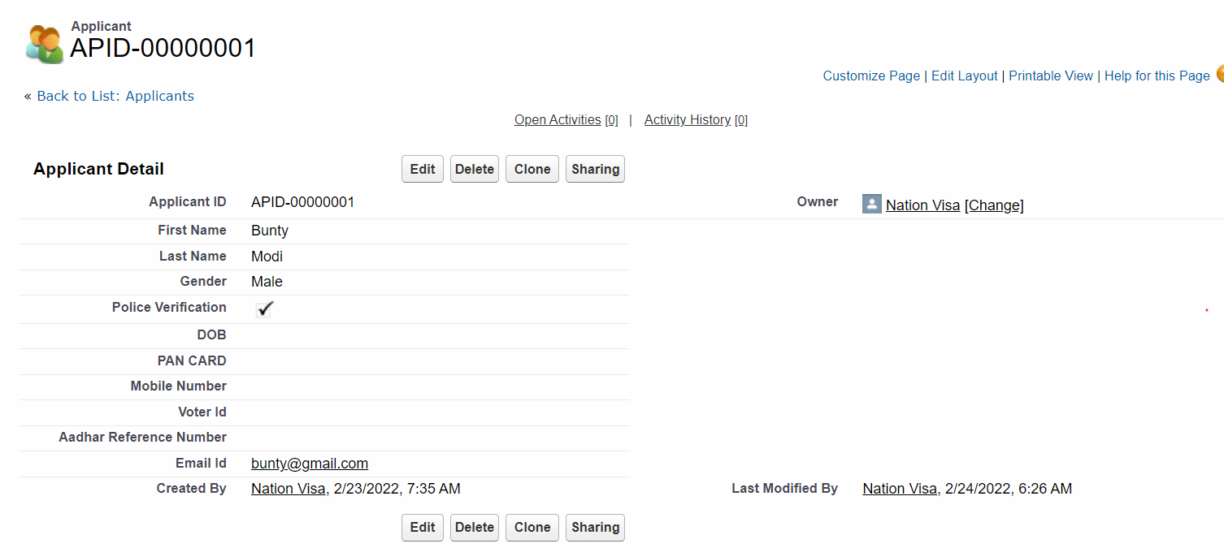



3] Edit Page

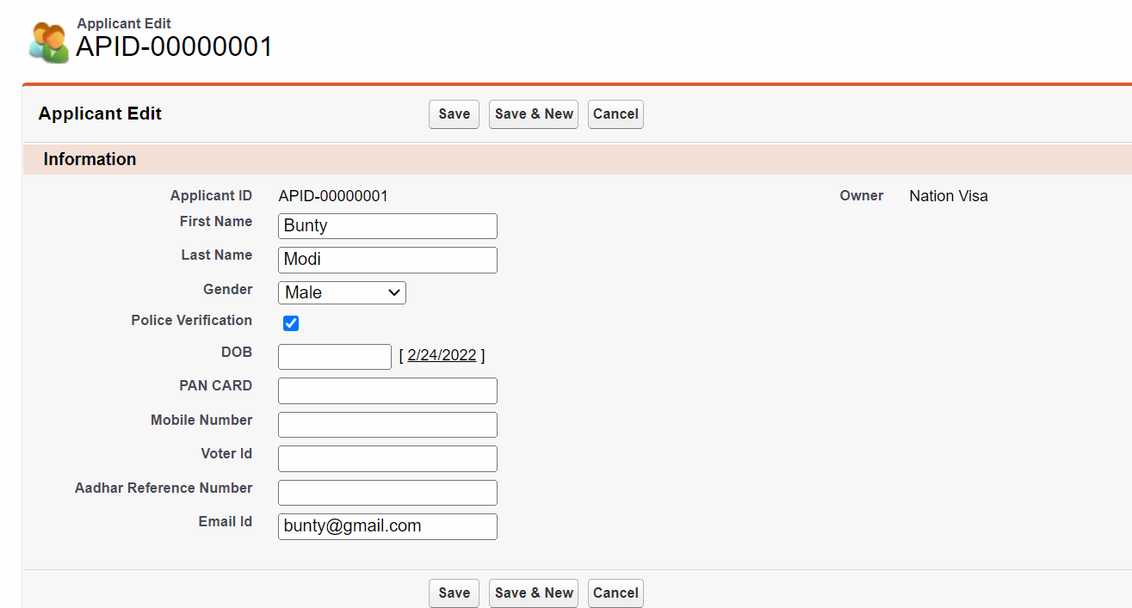



4] Related List

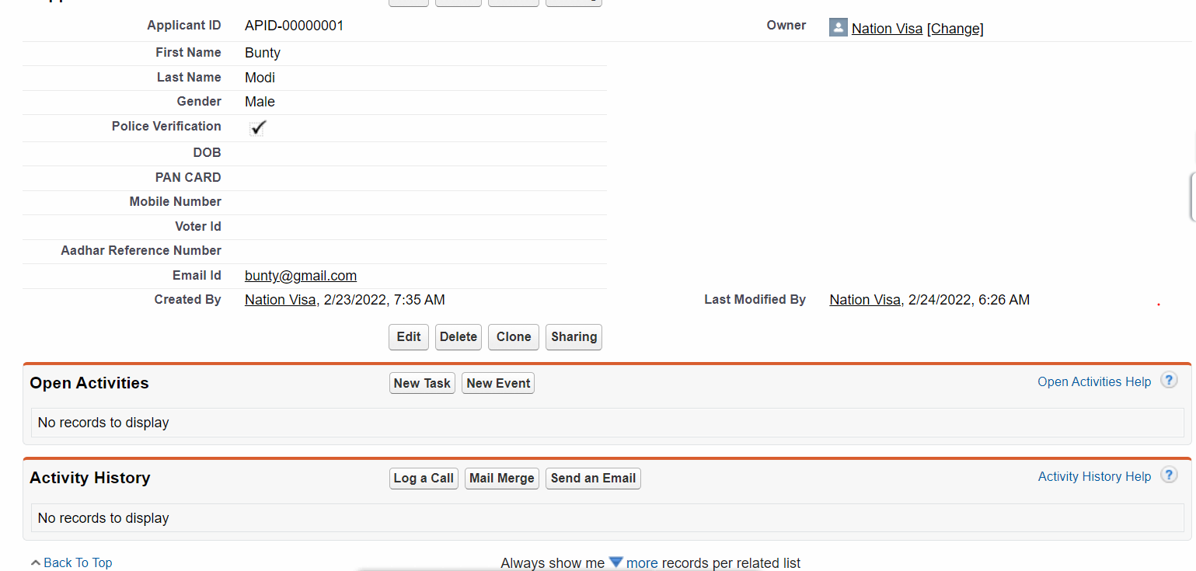



5] In-Line Editing

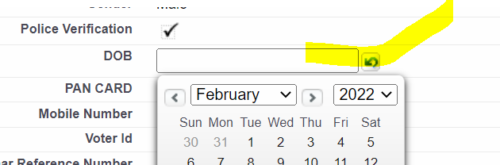

Don’t want In-Line Editing Facility:

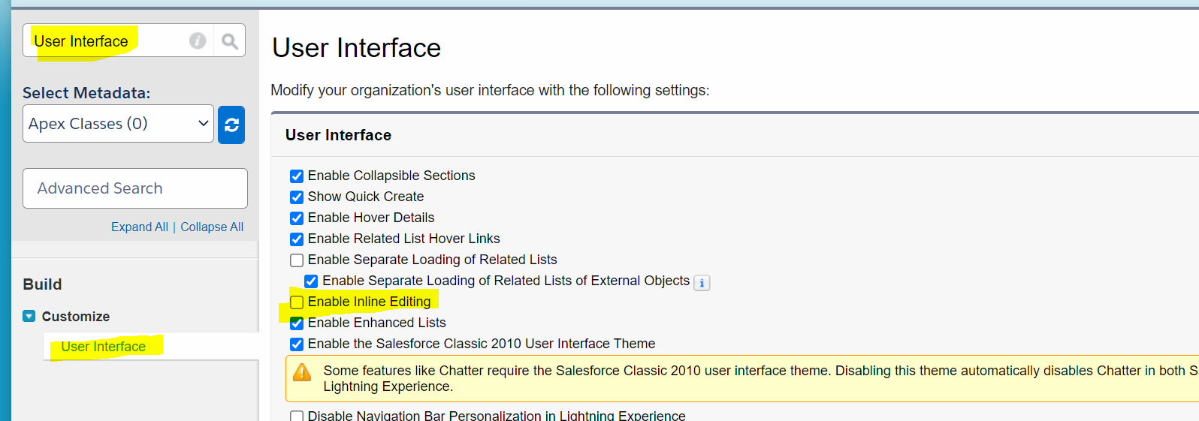

6] Enhanced Editing

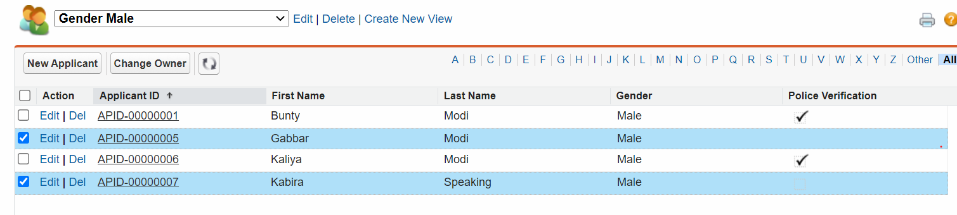

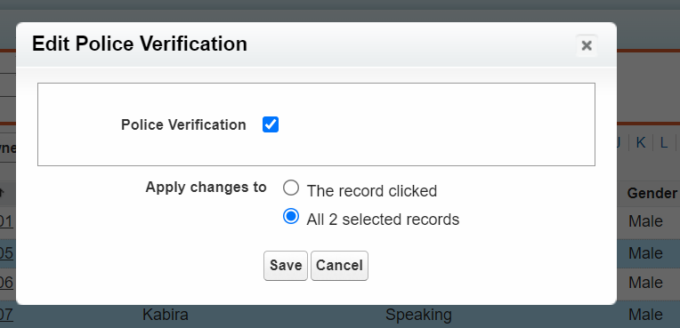

Don’t want This Enhanced Editing Facility:

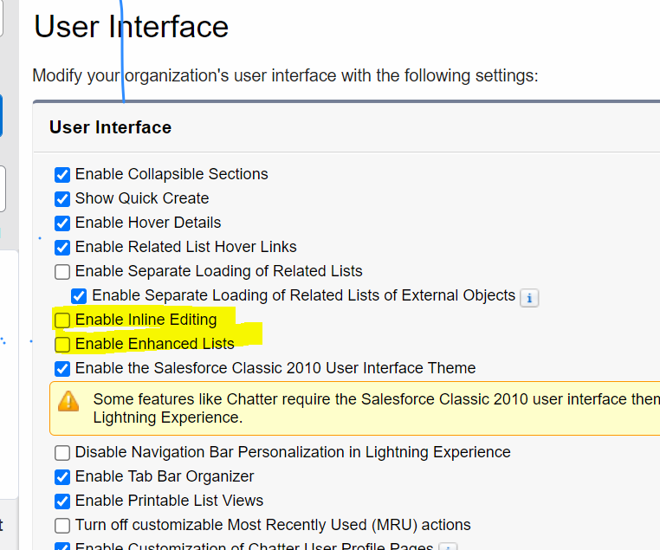

=======================================================

Created Date : 2/24/2022, 7:05 AM 🡪 America

Apna Time : 2/24/2022, 08:35 PM 🡪 India

America 🡪 PST = Pacific Standard Time

India 🡪 IST = Indian Standard Time

GMT🡪 Greenwitch Mean Time

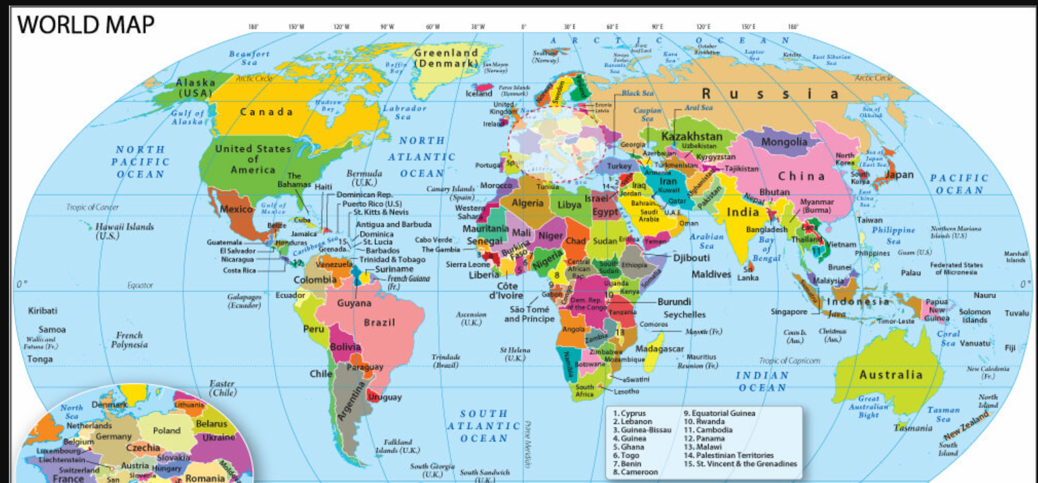



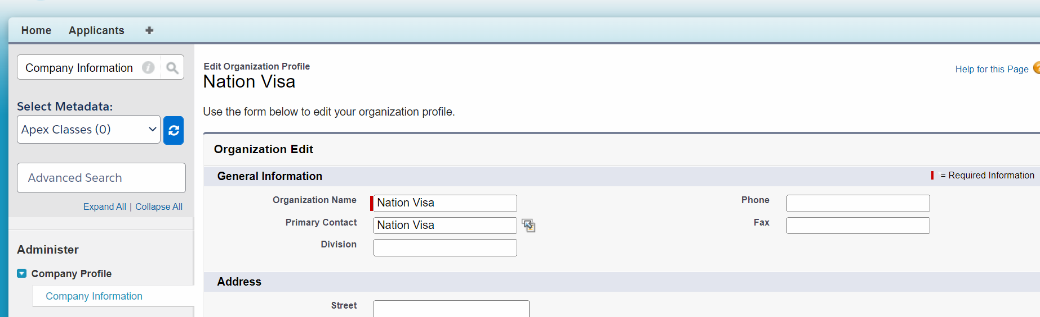

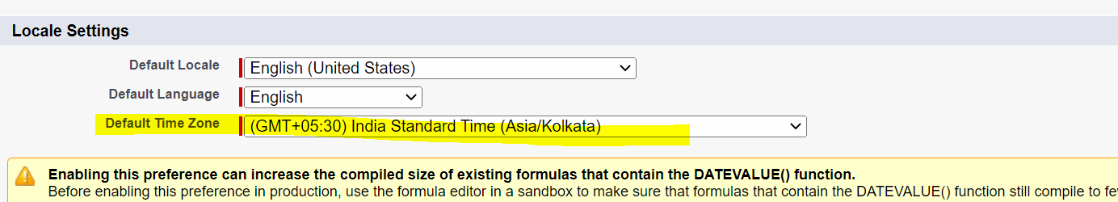

OR

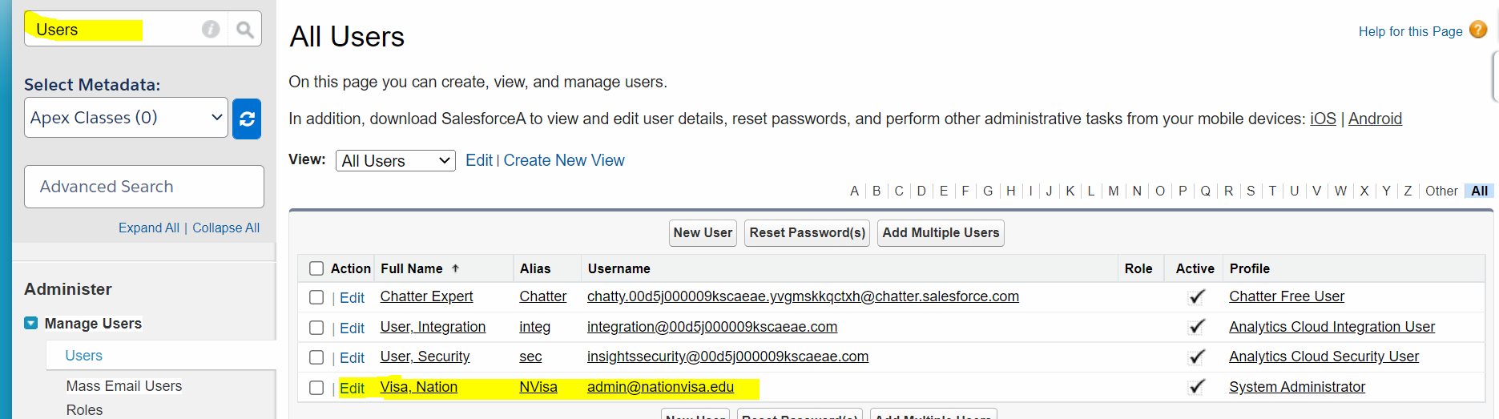

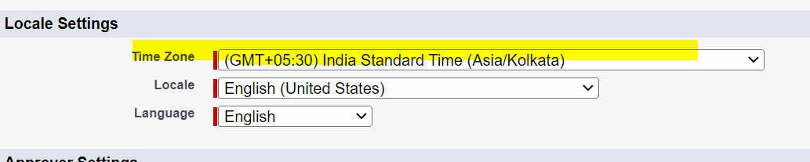

DOLLAR AND RUPEE

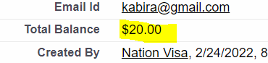

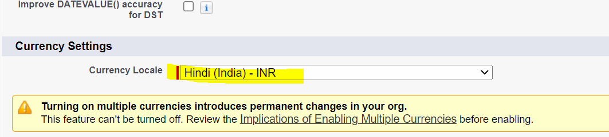



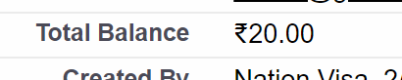

Aadhar Card : 123456654455

Aadhar Card : XXXXXXXX4455